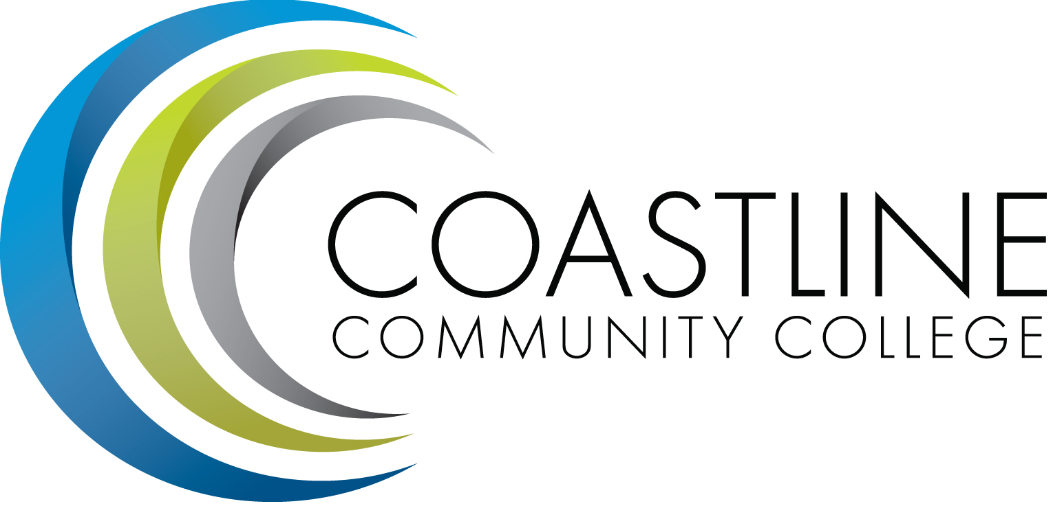

AGENDA
Coastline Management Meeting (CMT)
SPECIAL MEETING
July 19, 2017
9:30 a.m. – 12:00 p.m.
4th Floor Conference Room

- Closing the Loop: Management Retreat 2016…………………….......................(Retreat Planning Team)
- Management Retreat Agenda – July 24, 25………………………………………………(Lori/All)
- Personal Vision for Coastline…………………………………………………………………….(Lori)
- Working towards a shared vision for Coastline………………………………………….(Lori/All)
- Core Messages on Coastline..…………………………………………………………………….(Lori)

